Station 1: Maps of the Trail of Tears

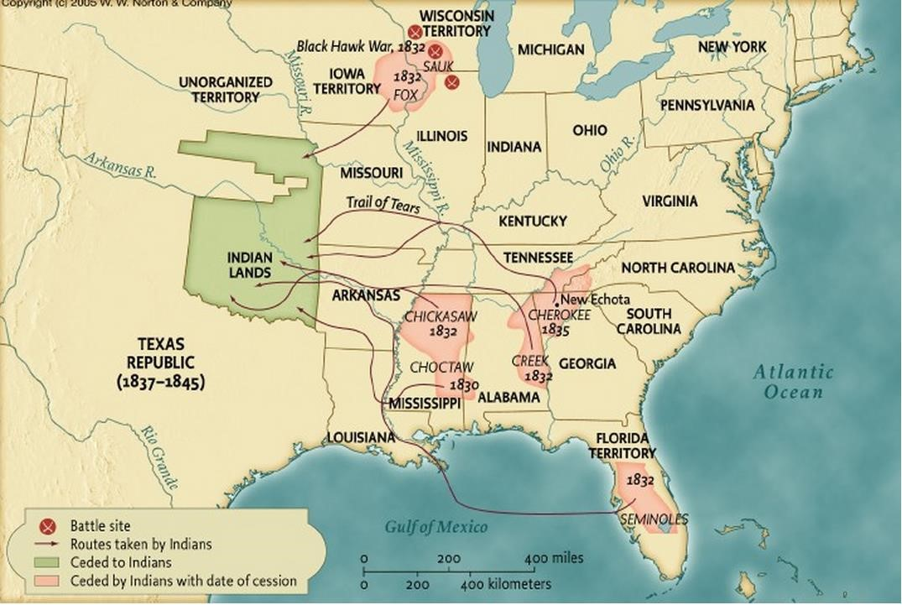

- According to the maps, how many total Native American Tribes were resettled to the “Indian Lands” in 1832? Name them.
- There were no railroads in 1832 to transport the Native Americans to their new lands. They travelled mostly by foot, covered wagon, horseback, or boat. From these maps, your knowledge of US history & geography, what do you think the journey was like for Native Americans? Use specific evidence from the maps to support your claims.

Station 2: Andrew Jackson’s Message to Congress about Indian Removal Act, December 6th 1830

1  2  3  4  5  6  7  8  9  10  11  12  13  14  15  16  17  18 | It gives me pleasure to announce to Congress that the benevolent policy of the Government, steadily pursued for nearly thirty years, in relation to the removal of the Indians beyond the white settlements is approaching to a happy consummation….The consequences of a speedy removal will be important to the United States, to individual States, and to the Indian themselves… It will place a dense and civilized population in large tracts of country now occupied by a few savage hunters….By opening the whole territory between Tennessee on the north and Louisiana on the south to the settlement of the whites it will incalculably strengthen the southwestern frontier... It will relieve the whole State of Mississippi and the western part of Alabama of Indian occupancy, and enable those States to advance rapidly in population, wealth, and power. It will separate the Indians from immediate contact with settlements of whites; free them from the power of the States; enable them to pursue happiness in their own way and under their own rude institutions; will retard the progress of decay, which is lessening their numbers, and perhaps cause them gradually, under the protection of the Government and through the influence of good counsels, to cast off their savage habits and become an interesting, civilized, and Christian community...What good man would prefer a country covered with forests and ranged by a few thousand savages to our extensive Republic, studded with cities, towns, and prosperous farms embellished with all the improvements which art can devise or industry execute, occupied by more than 12,000,000 happy people, and filled with all the blessings of liberty, civilization, and religion?....To save him from this alternative, or perhaps utter annihilation, the General Government kindly offers him a new home, and proposes to pay the whole expense of his removal and settlement.

1. Is Andrew Jackson in support of the Indian Removal Act or against it? Summarize four of his main arguments. Which argument do you think it the strongest? Explain.

Station 3: Supreme Court Cases
Worcester v. Georgia (1832) & Cherokee Nation v. Georgia (1831)

After the passing of the Indian Removal Act by President Johnson in 1830, Native American’s took their cause to the Supreme Court, hoping that the act would be ruled unconstitutional.
Cherokee Nation v. Georgia (1831) Ruling:

1  2  3  4  5  6  7  8 | A question of much more difficulty remains. Do the Cherokees constitute a foreign state in the sense of the constitution?... They are not a state of the Union ...not owing allegiance to the United States...The condition of the Indians in relation to the United States is, perhaps, unlike that of any other two people in existence... They acknowledge themselves, in their treaties, to be under the protection of the United States; they admit, that the United States shall have the sole and exclusive right of regulating the trade with them, and managing all their affairs as they think proper; and the Cherokees in particular... their relation to the United States resembles that of a ward (child) to his guardian. They look to our government for protection: rely upon its kindness and its power; appeal to it for relief to their wants; and address the president as their great father. They and their country are considered by foreign nations, as well as by ourselves, as being so completely under the sovereignty and dominion of the United States….

Worcester v. Georgia (1832) Ruling:

1  2  3  4  5 | …. consider the several Indian nations as distinct political communities, having territorial boundaries, within which their authority is exclusive, and having a right to all the lands within those boundaries, which is not only acknowledged, but guaranteed by the United States. The Cherokee Nation, then, is a distinct community, occupying its own territory, with boundaries accurately described, in which the laws of Georgia can have no force, and which the citizens of Georgia have no right to enter but with the permission of the  Cherokees themselves or in conformity with treaties and with the acts of Congress.

- According to Cherokee vs. Georgia, is the Cherokee Nation an independent nation? Use evidence to support your answer.
- According to Worcester vs. Georgia, is the Cherokee Nation an independent nation? Use evidence to support your answer.
- If the Cherokee nation is not an independent country, how can the Federal government justify their removal and resettlement?

Station 4: American author Ralph Waldo Emerson Letter to President Martin Van Buren in 1838
A PROTEST AGAINST THE REMOVAL OF THE CHEROKEE INDIANS FROM THE STATE OF GEORGIA LETTER TO MARTIN VAN BUREN, PRESIDENT OF THE UNITED STATES April 23,
1838.

SIR : The seat you fill places you in a relation of credit and nearness to every citizen. By right and natural position, every citizen is your friend...Sir, my communication respects the sinister rumors that fill this part of the country concerning the Cherokee people. The interest always felt in the Native population - an interest…. has been heightened in regard to this tribe. Even in our distant State some good rumor of the Cherokee worth and civility has arrived….we have witnessed with sympathy the painful labors of these Native Americans have worked to redeem their race from the doom of eternal inferiority….they have worked hard to become more civil and adopt the customs of the Caucasian race… So is it true then that which the newspapers tell us? Would we truly ask those who were there before us to move hundreds of miles without any legal cause simply because we want their lands? We seem to be committing a crime….a crime that deprives us as well as the Cherokees of a country… will the American government steal? Will it lie? Will it kill?.....

- Suggest two adjectives that you think describe the tone of Emerson’s letter. Provide textual evidence to support your answer.
- Does Emerson think that the Indian Removal Act is legal? What reasoning does he give? Provide textual evidence to support your answer.

Station 5: Trail of Tears –

In 1838 and 1839, large groups of Cherokee people migrated to the newly formed Indian territories along a pathway that would become known as the “Trail of Tears”. The migrants faced disease, hunger, and exhaustion on the forced march; 4,000 out of 15,000 Cherokee peoples died along the path.
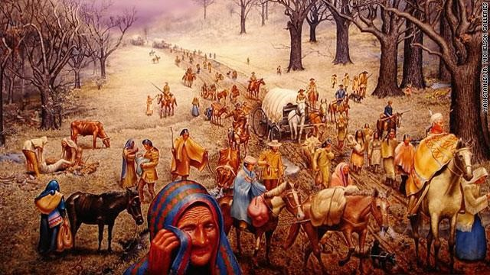

- WOPAQ/KTFD this image. (Words, Objects People, Actions Questions, and what does the author want us to Know, Think, Feel, Do?)
- Based on this painting, how would you describe the Cherokee Nation’s journey along the Trail of Tears? What stands out to you?

Station 6 – Samuel’s Memory, a story by 9 year old Samuel Rutledge, member of Cherokee Indian Tribe
It is Spring. The leaves are on the trees. I am playing with my friends when white men in uniforms ride up to our home. My mother calls me. I can tell by her voice that something is wrong. Some of the men ride off. My mother tells me to gather my things, but the men don't allow us time to get anything. My mother and I are taken by several men to where their horses are and are held there at gun point. From my mother I feel fear. I am filled with fear, too. What is going on? I was just playing, but now my family and my friends' families are gathered together and told to walk at the point of a bayonet.
They lead us to a stockade. They herd us into this pen like we are cattle. No one was given time to gather any possessions. The nights are still cold in the mountains and we do not have enough blankets to go around. My mother holds me at night to keep me warm.
We are in the stockade for several months before the soldiers suddenly tell us we are to follow them. We are led out of the stockade. The guards all have guns and are watching us closely. We walk. My mother keeps me close to her.
We walked for many days. I don't know how long it has been since we left our home, but the mountains are behind us. Each day, we start walking a little later. They bury the dead in shallow graves, because the ground is frozen. As we walk past white towns, the whites come out to watch us pass. No words are spoken to them. No words are said to us. Still, I wish they would stop staring. I wish it were them walking in this misery and I were watching them. It is because of them that we are walking. I don't understand why, but I know that much. They made us leave our homes. They made us walk to this new place we are heading in the middle of winter. I do not like these people. Still, they stare at me as I walk past.
We are all cold and the snow and ice seem to hound us, claiming our people one by one. We wait to die. My mother is coughing now. She looks worn. Her hands and face are burning hot. My aunts and uncles try to take care of me, so she can get better. When I went to sleep last night, my mother was hot and coughing worse than usual. When I woke up, she was cold. I tried to wake her up, but she lay there. The soft warmth she once was, she is no more. The soldiers make us continue walking. I know what it is to hate. I hate those white soldiers who took us from our home. I hate the soldiers who make us keep walking through the snow and ice toward this new home that none of us ever wanted. I hate the people who killed my father and mother. None of those white people are here to say they are sorry that I am alone. None of them care about me or my people. All they ever saw was the color of our skin. All I see is the color of theirs and I hate them.
Create a “story pyramid” for this excerpt that describes what it was like on the Trail of Tears.

__________
Main Character
___________ __________
Two Words describing character
__________ __________ __________ Three words that describe setting
__________ __________ __________ __________ Four words that describe the important events
__________ __________ __________ __________ __________
Five words that describe the main idea
Station 7: Excerpt from the closing paragraphs of an address made by a council of Cherokee people to the United States in July 1830.

1  2  3  4  5  6  7  8  9  10  11  12  13  14  15  16  17  18 | We are aware, that some persons suppose it will be for our advantage to remove beyond the Mississippi. We think otherwise. Our people universally think otherwise…. there is probably not an adult person in the Cherokee nation, who would think it best to remove…  We are not willing to remove; and if we could be brought to this extremity, it would be not by argument, not because our judgment was satisfied, not because our condition will be improved; but only because we cannot endure to be deprived of our national and individual rights and subjected to a process of intolerable oppression.  We wish to remain on the land of our fathers...we see nothing but ruin before us. The country west of the Arkansas territory is unknown to us. From what we can learn of it, we have no prepossessions in its favor. All the inviting parts of it, as we believe, are preoccupied by various Indian nations...They would regard us as intruders, and look upon us with an evil eye... All our neighbors, in case of our removal, though crowded into our near vicinity, would speak a language totally different from ours, and practice different customs…Were the country to which we are urged much better than it is represented to be and were it free from the objections which we have made to it, still it is not the land of our birth, nor of our affections. It contains neither the scenes of our childhood, nor the graves of our fathers.

- According to lines 1-8, how do the Cherokee people feel about the Indian Removal Act? Provide textual evidence to support your answer.
- Why are the Cherokee fearful of moving to the new lands? Paraphrase two of their reasons for being fearful of the removal to other lands. Provide textual evidence to support your claims.

